Algebra 1: Unit 13, Lesson 4

- The table of values for the function, $D(x)$, is shown.
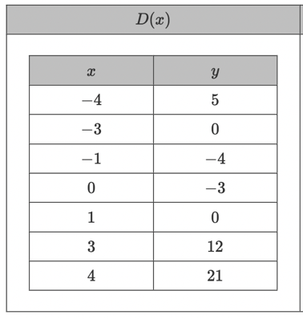
What kind of function is $D(x)$?

Quadratic function

- The equation, $y=450{(1.45)}^{x}$, represents exponential growth. What is the initial value of the function and the rate of growth?

$450$, $45\%$

- Consider the exponential decay function, $f\left(x\right)=17310{\left(0.898\right)}^{x}.$
What is the rate of decay?

$$10.2\%$$

